

**Module 5 Mastery Assessment Packet Tracer - Skills Integration Challenge**

# Introduction

In this Module 5 Mastery Assessment students will be asked to step-and configure the network and ACLs as needed. Refer to your notes for commands.

# Objectives

Subnet and configure addressing, Configure dynamic and static routing

Implement named access control lists.

# Assignment

In this challenge activity, you will finish the addressing scheme, configure routing, and implement named access control lists.

# Required Resources

Your Computer workstation

Cisco Packet Tracer (online)

Instructor Provided Packet Tracer file

## Packet Tracer - Skills Integration Challenge

# Topology

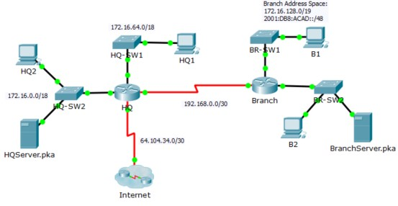

# Addressing Table

|  |  |  |  |  |
| --- | --- | --- | --- | --- |
| **Device** | **Interface** | **IP Address** | **Subnet Mask** | **Default Gateway** |
| **IPv6 Address / Prefix** | |
| HQ | G0/0 | 172.16.127.254 | 255.255.192.0 | N/A |
| G0/1 | 172.16.63.254 | 255.255.192.0 | N/A |
| S0/0/0 | 192.168.0.1 | 255.255.255.252 | N/A |
| S0/0/1 | 64.104.34.2 | 255.255.255.252 | 64.104.34.1 |
| Branch | G0/0 | 172.16.159.254 | 255.255.240.0 | N/A |
| 2001:DB8:ACAD:B1::1/64 | |
| G0/1 | 172.16.143.254 | 255.255.240.0 | N/A |
| 2001:DB8:ACAD:B2::1/64 | |
| S0/0/0 | 192.168.0.2 | 255.255.255.252 | N/A |
| HQ1 | NIC | 172.16.64.1 | 255.255.192.0 | 172.16.127.254 |
| HQ2 | NIC | 172.16.0.2 | 255.255.192.0 | 172.16.63.254 |
| HQServer.pka | NIC | 172.16.0.1 | 255.255.192.0 | 172.16.63.254 |
| B1 | NIC | 172.16.144.1 | 255.255.240.0 | 172.16.143.254 |
| 2001:DB8:ACAD:B1::2/64 | |  |
|  |  | 172.16.128.2 | 255.255.240.0 | 172.16.143.254 |
| B2 | NIC |  |  |  |
| 2001:DB8:ACAD:B2::2/64 | |  |

## Packet Tracer - Skills Integration Challenge

|  |  |  |  |  |
| --- | --- | --- | --- | --- |
| BranchServer.pka | NIC | 172.16.128.1 | 255.255.240.0 | 172.16.143.254 |
| 2001:DB8:ACAD:B2::3/64 | | 2001:DB8:ACAD:B2::  1 |

# Scenario

In this challenge activity, you will finish the addressing scheme, configure routing, and implement named access control lists.

# Requirements

1. Divide 172.16.128.0/19 into two equal subnets for use on **Branch**.
   1. Assign the last usable IPv4 address of the second subnet to the Gigabit Ethernet 0/0 interface.
   2. Assign the last usable IPv4 address of the first subnet to the Gigabit Ethernet 0/1 interface.
   3. Document the IPv4 addressing in the Addressing Table.
   4. Configure **Branch** with appropriate IPv4 addressing.
2. Configure **B1** with appropriate IPv4 address using the first available address of the network to which it is attached.
   1. Assign 2001:DB8:ACAD:B1::1/64 and 2001:DB8:ACAD:B2::1/64 to **Branch’s** Gigabit Ethernet 0/0 and Gigabit Ethernet 0/1, respectively.
3. Configure **Branch** with appropriate IPv6 addressing.
4. Configure **B1** and **B2** with appropriate IPv6 addresses using the first available address of the network to which it is attached.
5. Document the addressing in the Addressing Table.
6. Configure **HQ** and **Branch** with OSPFv2 routing for IPv4 according to the following criteria:
   * Assign the process ID 1.
   * Advertise all attached IPv4 networks. Do not advertise the link to the Internet.
   * Configure appropriate interfaces as passive.
7. Set a IPv4 default route on **HQ** which directs traffic to S0/0/1 interface. Redistribute the route to **Branch**.
8. Design an IPv4 named access list **HQServer** to prevent any computers attached to the Gigabit Ethernet 0/0 interface of the **Branch** router from accessing **HQServer.pka**. All other traffic is permitted. Configure the access list on the appropriate router, apply it to the appropriate interface and in the appropriate direction.
9. Design an IPv4 named access list **BranchServer** to prevent any computers attached to the Gigabit Ethernet 0/0 interface of the **HQ** router from accessing the HTTP and HTTPS service of the **Branch** server. All other traffic is permitted. Configure the access list on the appropriate router, apply it to the appropriate interface and in the appropriate direction.
10. Design an IPv6 access-list named **NO-B1** to prevent any IPv6 traffic originating on **B1** to reach the **BranchServer.pka**. No traffic should be permitted from **B1** to **BranchServer.pka**. Apply the IPv6 access to the most appropriate location (interface and direction).